# Dice, Number, Rolling, Roulette, Roll, RecreationDice, Number, Rolling, Roulette, Roll, RecreationDice, Number, Rolling, Roulette, Roll, Recreationsmiley clipart

# [Image result for smiley, clipart](https://www.google.com/url?sa=i&rct=j&q=&esrc=s&source=images&cd=&ved=2ahUKEwie9OW5_8DaAhVMlxQKHRPMAI4QjRx6BAgAEAU&url=https://www.pinterest.com/pin/85427724158945792/&psig=AOvVaw12Ds-n9_7NHX3cQNRPvTvI&ust=1524043673786533)smiley clipartDice, Number, Rolling, Roulette, Roll, RecreationDice, Number, Rolling, Roulette, Roll, RecreationDice, Number, Rolling, Roulette, Roll, Recreation **[smiley clip art - Free Large Imagessmiley clip art - Free Large Images](http://www.freelargeimages.com/smiley-clip-art-1863/)**

Notið einn tening. Ef þið vitið ekki svarið megið þið spyrja vin og svara svo. Svarið með heilum setningum og segið hvað er á myndunum.

BYRJA

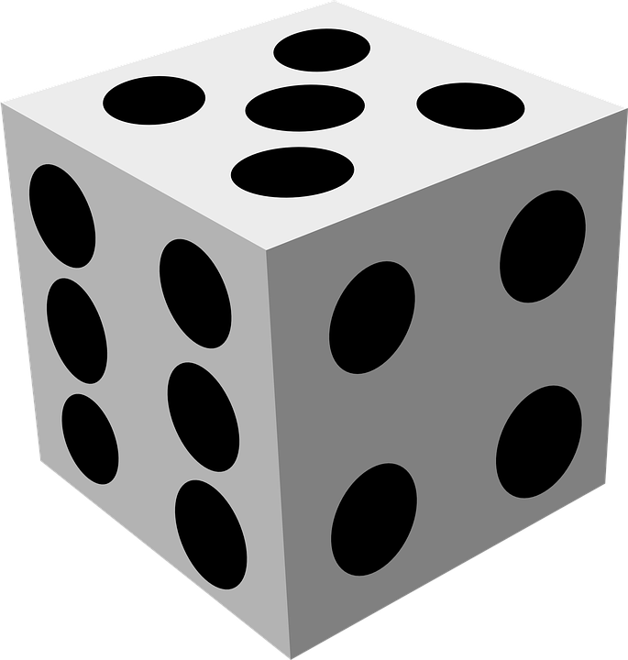

TITILL

ÞÚ VARST FYRSTUR Í MARK

a